

Programme | : | M.Tech Int Software Engineering | Semester | : | Fall 2026-2027
Course | : | Database Systems Lab | Code | : | IASWE206
Faculty | : | Dr. M. Premalatha | Slot | : | L31+L32
NAME:Nathan Anthony.A
REG NO:25MIS1113
Ex. No. 4
Date: 20-07-2026
SQL Basics – Aggregation Function

Note:
LMS Submission Format [Word File]
Regno, name
Course code, course title
Slot
Faculty Name
Question
SQL Query – Text Format (Copy Paste)
Screenshot

Ex:
Question:
create a student table with attributes regno, name, mobno and dob with appropriate datatypes and sizes

Query:
SQL> create table student_mp(regno varchar(4), sname char(10), mobno number(10), dob date);
Table created.

Screenshot:

SQL> desc student_mp
Name Null? Type
----------------------------------------- -------- ------------
REGNO VARCHAR2(4)
SNAME CHAR(10)
MOBNO NUMBER(10)
DOB DATE
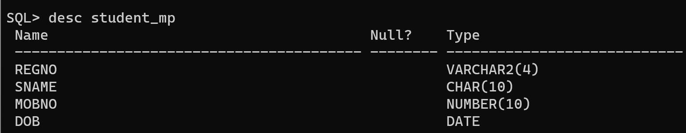

Note: Create the tables with key constraints. All further exercises will be asked from the following schema only. Kindly create the table with a minimum of 7 records with valid values.

school(school_id, school_name)
student(regno, sname, cgpa, school_id)
course(ccode, cname, credits, school_id)
faculty(empid, fname, designation, salary, school_id)
course_student_faculty(regno, ccode, fid, grade)

creating the tables:

Query:

SQL> create table school(school_id number(3)primary key,school_name varchar2(50)not null);

Table created.

SQL> create table student_13(regno varchar2(10)primary key,sname varchar2(50)not null,cgpa number(3,2) check(cgpa between 0 and 10),school_id number(3),constraint fk_student_school foreign key(school_id) references school(school_id));

Table created.

SQL> create table course(ccode varchar2(10) primary key,cname varchar2(50) not null,credits number(2) check(credits>0),school_id number(3),constraint fk_course_school foreign key(school_id) references school(school_id));

Table created.

SQL> create table faculty(empid number(4)primary key,fname varchar2(50) not null,designation varchar2(30),salary number(10,2),school_id number(3),constraint fk_faculty_school foreign key(school_id) references school(school_id));

Table created.

SQL> create table course_student_faculty(regno varchar2(10),ccode varchar2(10),fid number(4),grade char(2),constraint pk_csf primary key(regno,ccode,fid),constraint fk_csf_student_13 foreign key(regno) references student_13(regno),constraint fk_csf_course foreign key(ccode)references course(ccode),constraint fk_csf_faculty foreign key(fid) references faculty(empid));

Table created.

SQL> desc school;
Name Null? Type
----------------------------------------- -------- ----------------------------
SCHOOL_ID NOT NULL NUMBER(3)
SCHOOL_NAME NOT NULL VARCHAR2(50)

SQL> desc student_13;
Name Null? Type
----------------------------------------- -------- ----------------------------
REGNO NOT NULL VARCHAR2(10)
SNAME NOT NULL VARCHAR2(50)
CGPA NUMBER(3,2)
SCHOOL_ID NUMBER(3)

SQL> desc course;
Name Null? Type
----------------------------------------- -------- ----------------------------
CCODE NOT NULL VARCHAR2(10)
CNAME NOT NULL VARCHAR2(50)
CREDITS NUMBER(2)
SCHOOL_ID NUMBER(3)

SQL> desc faculty;
Name Null? Type
----------------------------------------- -------- ----------------------------
EMPID NOT NULL NUMBER(4)
FNAME NOT NULL VARCHAR2(50)
DESIGNATION VARCHAR2(30)
SALARY NUMBER(10,2)
SCHOOL_ID NUMBER(3)

SQL> desc course_student_faculty;
Name Null? Type
----------------------------------------- -------- ----------------------------
REGNO NOT NULL VARCHAR2(10)
CCODE NOT NULL VARCHAR2(10)
FID NOT NULL NUMBER(4)
GRADE CHAR(2)

SQL> insert into school values(101,'School of Computing');

1 row created.

SQL> insert into school values(102,'School of Mechanical');

1 row created.

SQL> insert into school values(103,'School of Electrical');

1 row created.

SQL> insert into school values(104,'School of Civil');

1 row created.

SQL> insert into school values(105,'School of Management');

1 row created.

SQL> insert into school values(106,'School of Electronics');

1 row created.

SQL> insert into school values(107,'School of Science');

1 row created.

SQL> select*from school;

SCHOOL_ID SCHOOL_NAME
---------- --------------------------------------------------
101 School of Computing
102 School of Mechanical
103 School of Electrical
104 School of Civil
105 School of Management
106 School of Electronics
107 School of Science

7 rows selected.

SQL> insert into school_13 values('S101','Amit',9.10,101);
insert into school_13 values('S101','Amit',9.10,101)
*
ERROR at line 1:
ORA-00942: table or view does not exist

SQL> insert into student_13 values('S101','Amit',9.10,101);

1 row created.

SQL> insert into student_13 values('S102','Bharath',8.60,101);

1 row created.

SQL> insert into student_13 values('S103','Charan',7.90,102);

1 row created.

SQL> insert into student_13 values('S104','Deepa',9.40,103);

1 row created.

SQL> insert into student_13 values('S105','Esha',8.20,104);

1 row created.

SQL> insert into student_13 values('S106','Farhan',6.80,105);

1 row created.

SQL> insert into student_13 values('S107','Gokul',9.70,101);

1 row created.

SQL> select*from student_13;

REGNO SNAME CGPA
---------- -------------------------------------------------- ----------
SCHOOL_ID
----------
S101 Amit 9.1
101

S102 Bharath 8.6
101

S103 Charan 7.9
102

REGNO SNAME CGPA
---------- -------------------------------------------------- ----------
SCHOOL_ID
----------
S104 Deepa 9.4
103

S105 Esha 8.2
104

S106 Farhan 6.8
105

REGNO SNAME CGPA
---------- -------------------------------------------------- ----------
SCHOOL_ID
----------
S107 Gokul 9.7
101

7 rows selected.

SQL> insert into course values('C101','DBMS',4,101);

1 row created.

SQL> insert into course values('C101','DBMS',4,101);
insert into course values('C101','DBMS',4,101)
*
ERROR at line 1:
ORA-00001: unique constraint (SYSTEM.SYS_C007034) violated

SQL> insert into course values('C102','Java',3,101);

1 row created.

SQL> insert into course values('C102','Java',3,101);
insert into course values('C102','Java',3,101)
*
ERROR at line 1:
ORA-00001: unique constraint (SYSTEM.SYS_C007034) violated

SQL> insert into course values('C103','Mechanics',4,102);

1 row created.

SQL> insert into course values('C104','Circuits',5,103);

1 row created.

SQL> insert into course values('C105','Surveying',3,104);

1 row created.

SQL> insert into course values('C106','Management',2,105);

1 row created.

SQL> insert into course values('C107','Physics',4,107);

1 row created.

SQL> select*from course;

CCODE CNAME CREDITS
---------- -------------------------------------------------- ----------
SCHOOL_ID
----------
C101 DBMS 4
101

C102 Java 3
101

C103 Mechanics 4
102

CCODE CNAME CREDITS
---------- -------------------------------------------------- ----------
SCHOOL_ID
----------
C104 Circuits 5
103

C105 Surveying 3
104

C106 Management 2
105

CCODE CNAME CREDITS
---------- -------------------------------------------------- ----------
SCHOOL_ID
----------
C107 Physics 4
107

7 rows selected.

SQL> insert into faculty values(201,'Ramesh','Professor',120000,101);

1 row created.

SQL> insert into faculty values(202,'Suresh','Associate Professor',98000,101);

1 row created.

SQL> insert into faculty values(203,'Meena','Assistant Professor',75000,102);

1 row created.

SQL> insert into faculty values(204,'Kiran','Professor',140000,103);

1 row created.

SQL> insert into faculty values(205,'Anita','Lecturer',65000,104);

1 row created.

SQL> insert into faculty values(206,'Joseph','Professor',160000,105);

1 row created.

SQL> insert into faculty values(207,'Priya','Associate Professor',110000,107);

1 row created.

SQL> select*from faculty;

EMPID FNAME
---------- --------------------------------------------------
DESIGNATION SALARY SCHOOL_ID
------------------------------ ---------- ----------
201 Ramesh
Professor 120000 101

202 Suresh
Associate Professor 98000 101

203 Meena
Assistant Professor 75000 102

EMPID FNAME
---------- --------------------------------------------------
DESIGNATION SALARY SCHOOL_ID
------------------------------ ---------- ----------
204 Kiran
Professor 140000 103

205 Anita
Lecturer 65000 104

206 Joseph
Professor 160000 105

EMPID FNAME
---------- --------------------------------------------------
DESIGNATION SALARY SCHOOL_ID
------------------------------ ---------- ----------
207 Priya
Associate Professor 110000 107

7 rows selected.

SQL> insert into course_student_faculty values('S101','C101',201,'A');

1 row created.

SQL> insert into course_student_faculty values('S102','C102',202,'B');

1 row created.

SQL> insert into course_student_faculty values('S103','C103',203,'A');

1 row created.

SQL> insert into course_student_faculty values('S104','C104',204,'A');

1 row created.

SQL> insert into course_student_faculty values('S105','C105',205,'B');

1 row created.

SQL> insert into course_student_faculty values('S106','C106',206,'C');

1 row created.

SQL> insert into course_student_faculty values('S107','C101',201,'A');

1 row created.

SQL> select*from course_student_faculty;

REGNO CCODE FID GR
---------- ---------- ---------- --
S101 C101 201 A
S102 C102 202 B
S103 C103 203 A
S104 C104 204 A
S105 C105 205 B
S106 C106 206 C
S107 C101 201 A

7 rows selected.

SQL> commit;

Commit complete.

Screenshot:

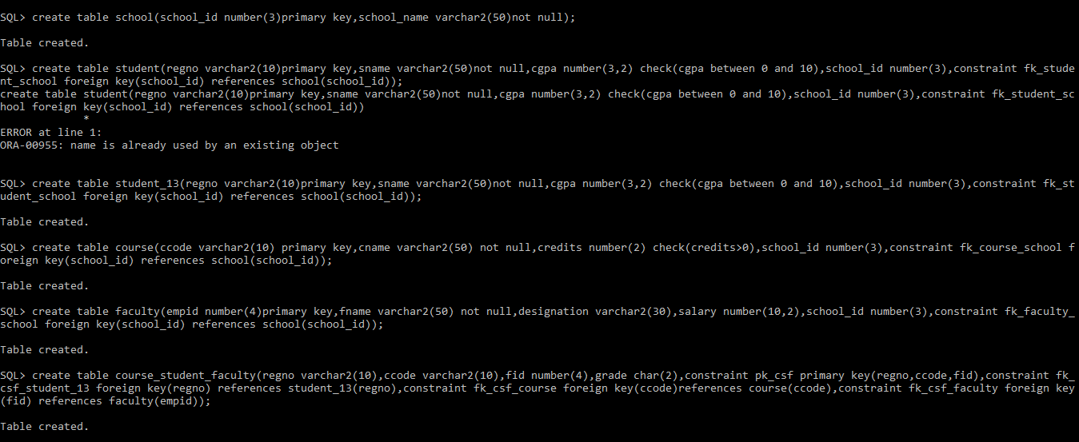
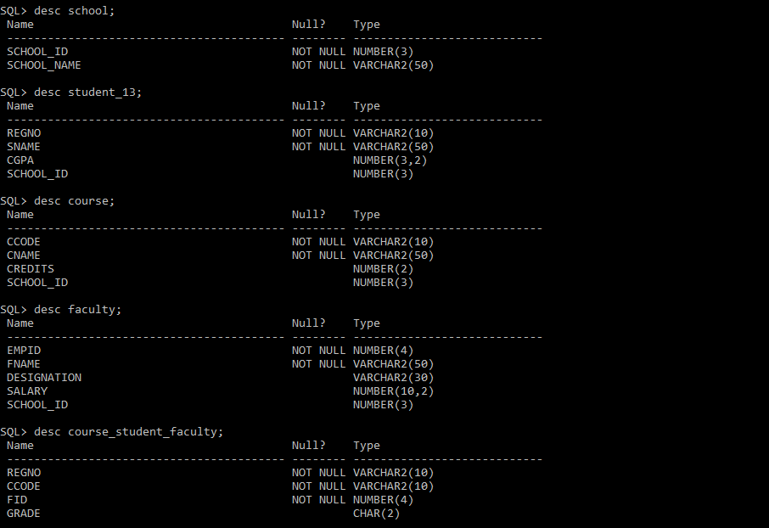
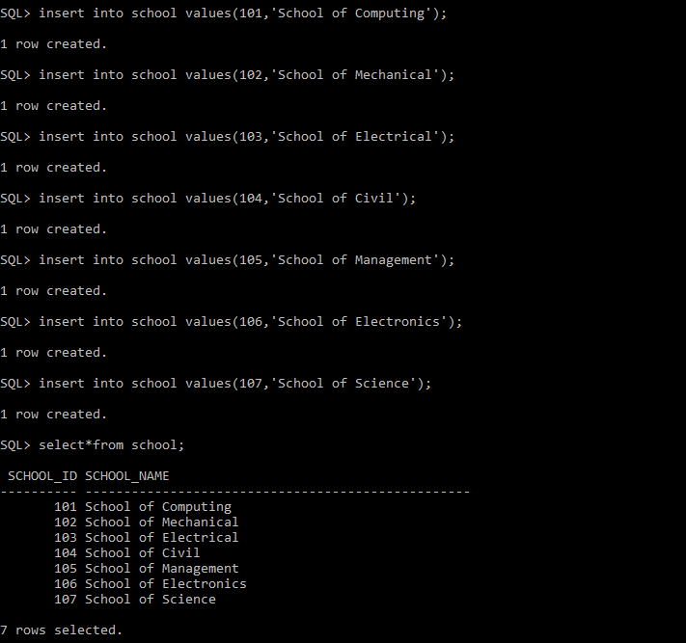
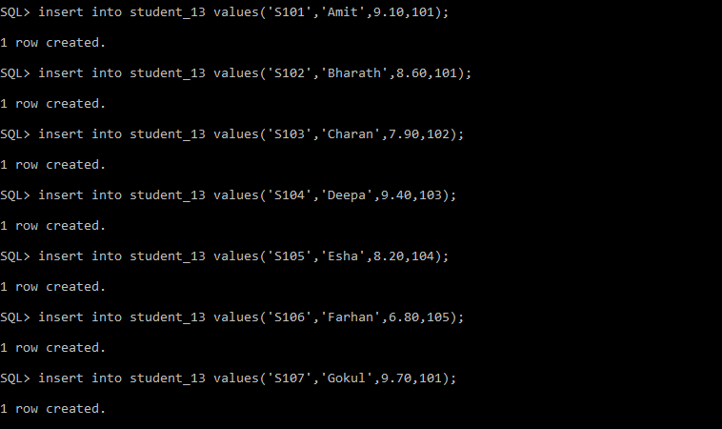
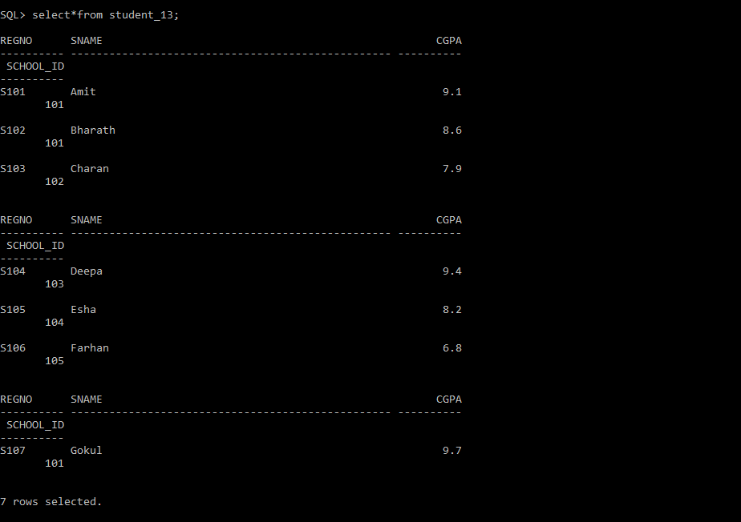
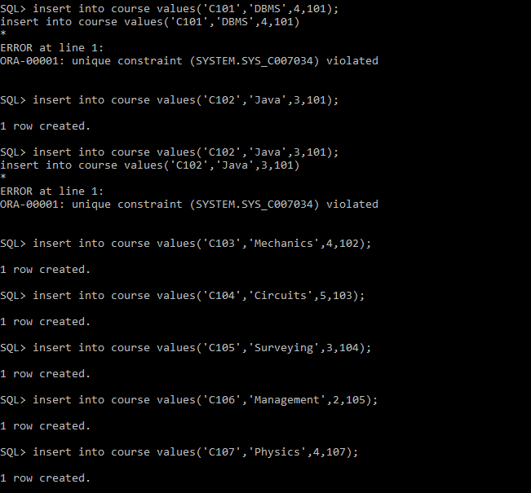
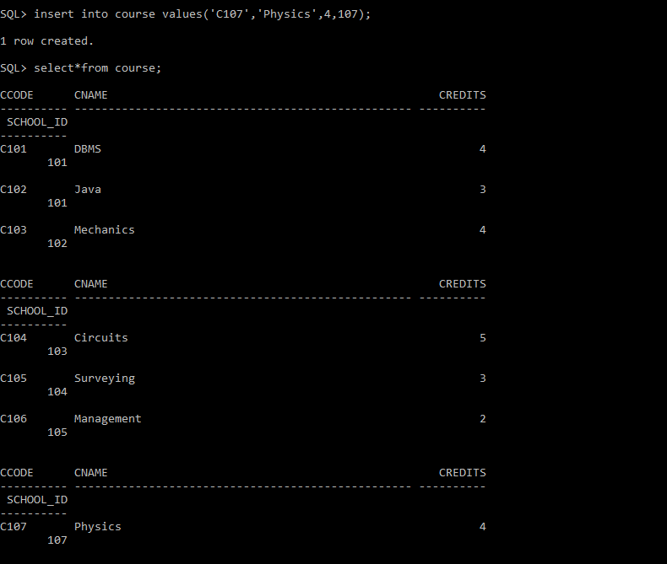
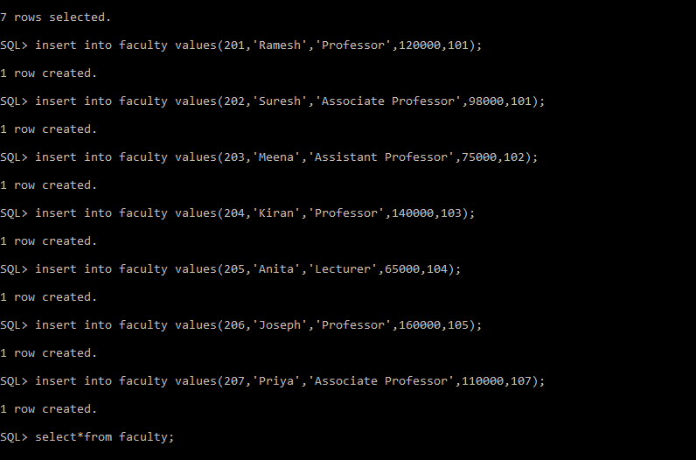
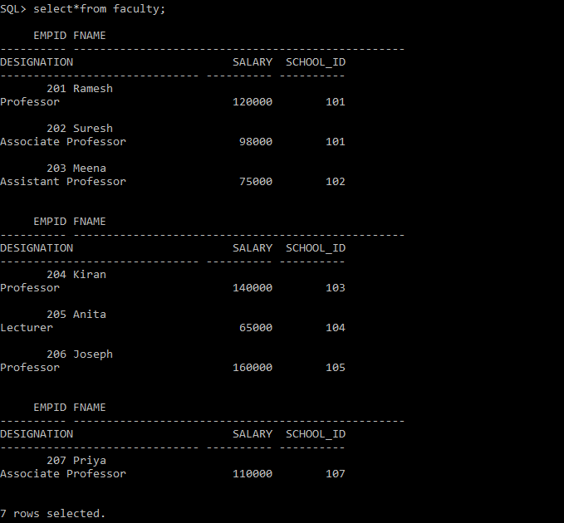
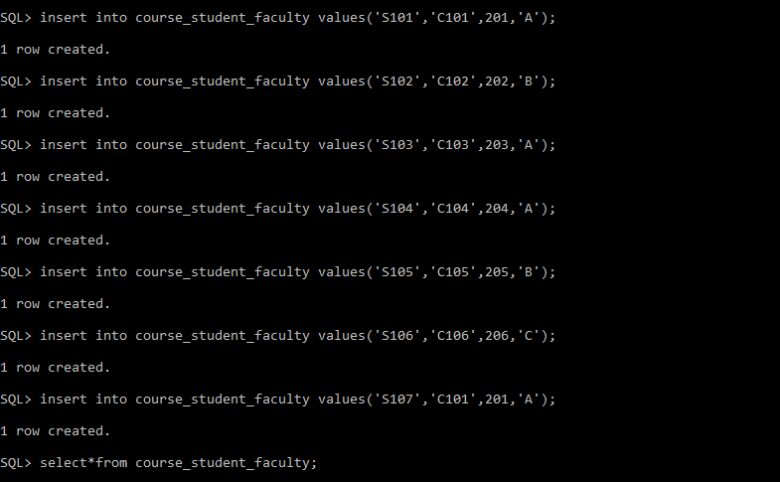
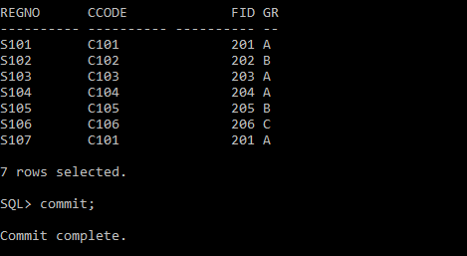

- Find the maximum cgpa out of all the students
Query:

SQL> select max(cgpa)as maximum_cgpa from student_13;

MAXIMUM_CGPA
------------
9.7
Screenshot:
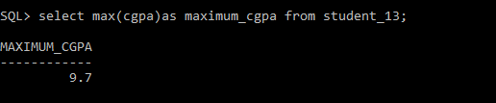
- Find the school_id of the student who has the least cgpa
Query:
SQL> select school_id from student_13 where cgpa=(select min(cgpa)from student_13);

SCHOOL_ID
----------
105
Screenshot:
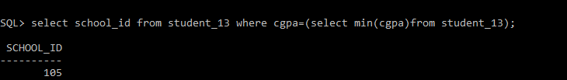
- Display the avg cgpa scored by the scope students.
Query:

SQL> select avg(s.cgpa)as average_cgpa from student_13 s join school sc on s.school_id=sc.school_id where sc.school_name='School of Computing';

AVERAGE_CGPA
------------
9.13333333
Screenshot:
- Identify the course(s) name with maximum credits.
Query:

SQL> select cname from course where credits =(select max(credits) from course);

CNAME
--------------------------------------------------
Circuits

Screenshot:
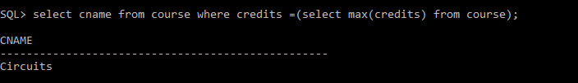
- List the name of the faculty who receive minimum salary.
Query:

SQL> select fname from faculty where salary=(select min(salary)from faculty);

FNAME
--------------------------------------------------
Anita

Screenshot:
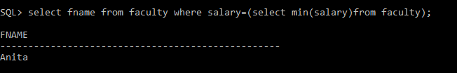
- List the count of employees who receive more than 1 lakh as salary.
Query:

SQL> select count(*) as total_faculty from faculty where salary>100000;

TOTAL_FACULTY
-------------
4

Screenshot:

- Find the total number of students.
Query:
SQL> select count(*) as total_students from student_13;

TOTAL_STUDENTS
--------------
7

Screenshot:
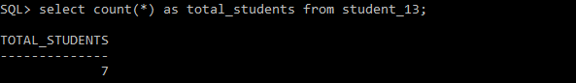
- Find the average CGPA of all students.
Query:
SQL> select*from student_13 order by cgpa asc;

REGNO SNAME CGPA
---------- -------------------------------------------------- ----------
SCHOOL_ID
----------
S106 Farhan 6.8
105

S103 Charan 7.9
102

S105 Esha 8.2
104

REGNO SNAME CGPA
---------- -------------------------------------------------- ----------
SCHOOL_ID
----------
S102 Bharath 8.6
101

S101 Amit 9.1
101

S104 Deepa 9.4
103

REGNO SNAME CGPA
---------- -------------------------------------------------- ----------
SCHOOL_ID
----------
S107 Gokul 9.7
101

7 rows selected.

Screenshot:
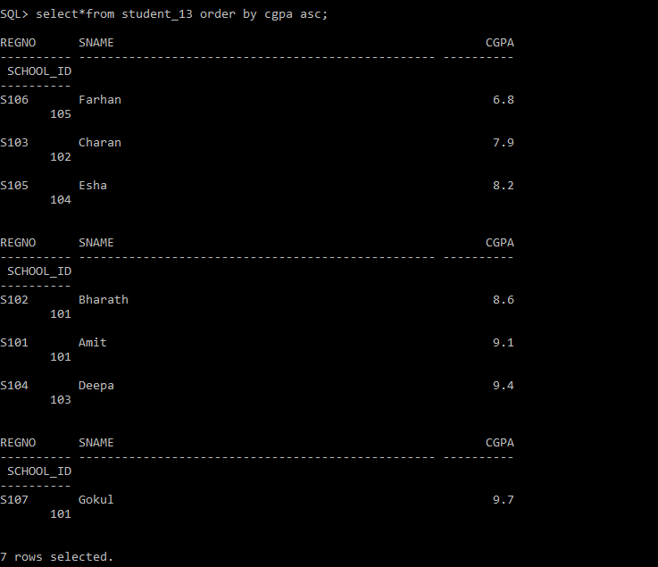
- Find the highest and lowest CGPA among all students.
Query:
SQL> select*from faculty order by salary desc;

EMPID FNAME
---------- --------------------------------------------------
DESIGNATION SALARY SCHOOL_ID
------------------------------ ---------- ----------
206 Joseph
Professor 160000 105

204 Kiran
Professor 140000 103

201 Ramesh
Professor 120000 101

EMPID FNAME
---------- --------------------------------------------------
DESIGNATION SALARY SCHOOL_ID
------------------------------ ---------- ----------
207 Priya
Associate Professor 110000 107

202 Suresh
Associate Professor 98000 101

203 Meena
Assistant Professor 75000 102

EMPID FNAME
---------- --------------------------------------------------
DESIGNATION SALARY SCHOOL_ID
------------------------------ ---------- ----------
205 Anita
Lecturer 65000 104

7 rows selected.

Screenshot:
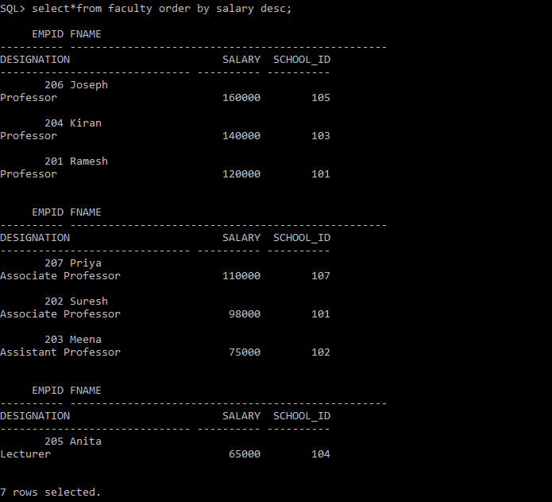
- Display the number of students in each school.
Query:

SQL> select sname from student_13 where cgpa>8.5;

SNAME
--------------------------------------------------
Amit
Bharath
Deepa
Gokul

Screenshot:
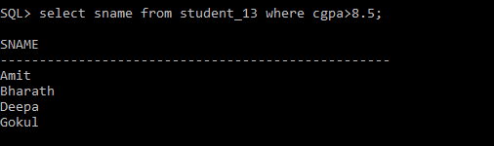
- Display the average CGPA of students in each school.
Query:

SQL> select cname,credits from course where credits>=4;

CNAME CREDITS
-------------------------------------------------- ----------
DBMS 4
Mechanics 4
Circuits 5
Physics 4

Screenshot:
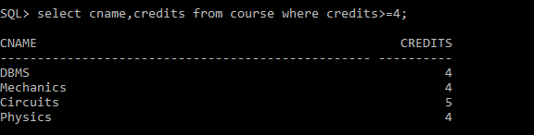
- List the school IDs having more than 25 students.
Query:

SQL> select f.fname from faculty f join school s on f.school_id=s.school_id where s.school_name='School of Computing';

FNAME
--------------------------------------------------
Ramesh
Suresh

Screenshot:
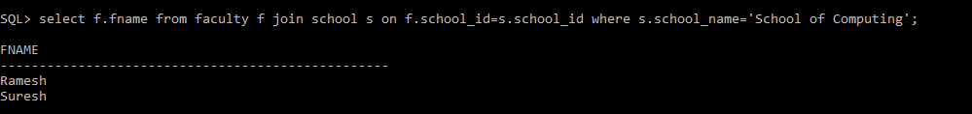
- List the school IDs where the average course credits are greater than 3.
Query:
SQL> select s.sname,c.cname,csf.grade from student_13 s join course_student_faculty csf on s.regno=csf.regno join course c on csf.ccode=c.ccode;

SNAME
--------------------------------------------------
CNAME GR
-------------------------------------------------- --
Amit
DBMS A

Bharath
Java B

Charan
Mechanics A

SNAME
--------------------------------------------------
CNAME GR
-------------------------------------------------- --
Deepa
Circuits A

Esha
Surveying B

Farhan
Management C

SNAME
--------------------------------------------------
CNAME GR
-------------------------------------------------- --
Gokul
DBMS A

7 rows selected.

Screenshot:
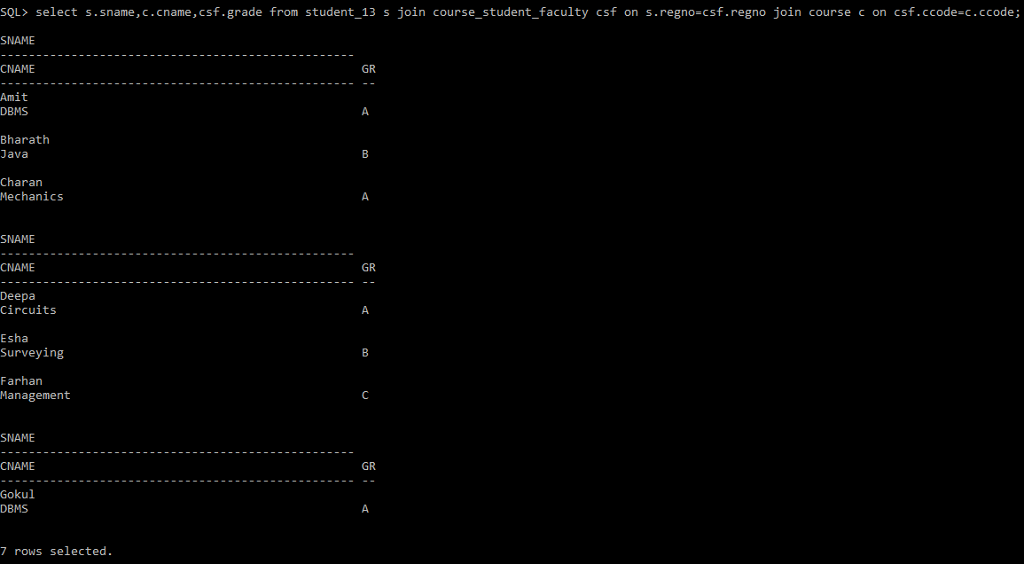
- List the designations having more than five faculty members.
Query:
SQL> select f.fname,c.cname,s.sname from faculty f join course_student_faculty csf on f.empid=csf.fid join course c on csf.ccode=c.ccode join student_13 s on csf.regno=s.regno;

FNAME
--------------------------------------------------
CNAME
--------------------------------------------------
SNAME
--------------------------------------------------
Ramesh
DBMS
Amit

Suresh
Java
Bharath

FNAME
--------------------------------------------------
CNAME
--------------------------------------------------
SNAME
--------------------------------------------------

Meena
Mechanics
Charan

Kiran
Circuits

FNAME
--------------------------------------------------
CNAME
--------------------------------------------------
SNAME
--------------------------------------------------
Deepa

Anita
Surveying
Esha

Joseph

FNAME
--------------------------------------------------
CNAME
--------------------------------------------------
SNAME
--------------------------------------------------
Management
Farhan

Ramesh
DBMS
Gokul

7 rows selected.
- List the faculty IDs who have handled more than three course registrations.
Query:

SQL> select s.sname from student_13 s join course_student_faculty csf on s.regno=csf.regno where csf.grade ='A';

SNAME
--------------------------------------------------
Amit
Charan
Deepa
Gokul

Screenshot:
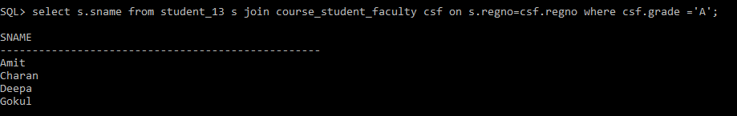
- List the school IDs where the average CGPA is greater than 8.5.
Query:
SQL> select c.cname,f.fname from course c join course_student_faculty csf on c.ccode=csf.ccode join faculty f on csf.fid=f.empid;

CNAME
--------------------------------------------------
FNAME
--------------------------------------------------
DBMS
Ramesh

Java
Suresh

Mechanics
Meena

CNAME
--------------------------------------------------
FNAME
--------------------------------------------------
Circuits
Kiran

Surveying
Anita

Management
Joseph

CNAME
--------------------------------------------------
FNAME
--------------------------------------------------
DBMS
Ramesh

7 rows selected.

Screenshot:
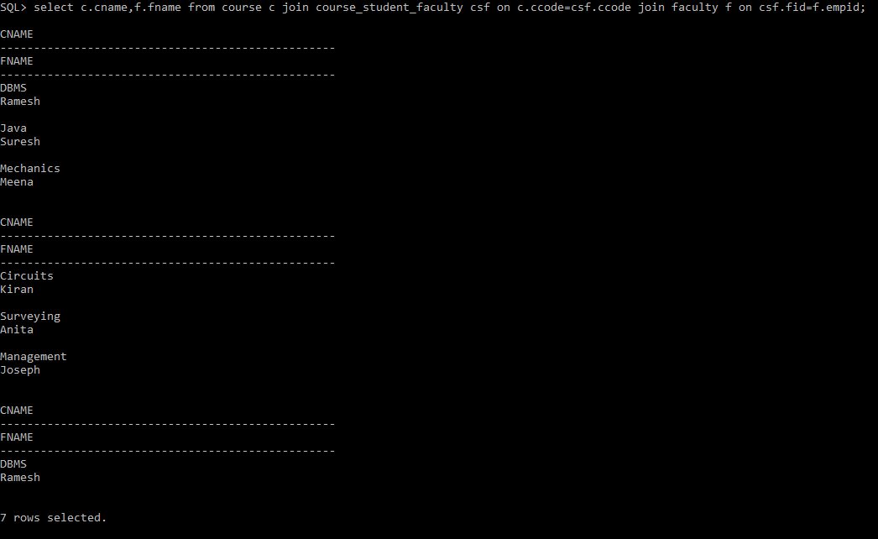
- Display the school IDs where the total credits offered exceed 20.
Query:
SQL> select s.sname from student_13 s join course_student_faculty csf on s.regno=csf.regno join course c on csf.ccode=c.ccode where c.cname='DBMS';

SNAME
--------------------------------------------------
Amit
Gokul

Screenshot:
- Display the course codes in which more than 10 students are enrolled.
Query:

SQL> select avg(salary)as average_salary from faculty;

AVERAGE_SALARY
--------------
109714.286

Screenshot:
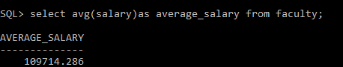
- Find the name of the school that have the maximum salary
Query:

SQL> select s.school_name,count(c.ccode)as total_courses from school s join course c on s.school_id=c.school_id group by s.school_name;

SCHOOL_NAME TOTAL_COURSES
-------------------------------------------------- -------------
School of Science 1
School of Mechanical 1
School of Civil 1
School of Computing 2
School of Management 1
School of Electrical 1

6 rows selected.

Screenshot:
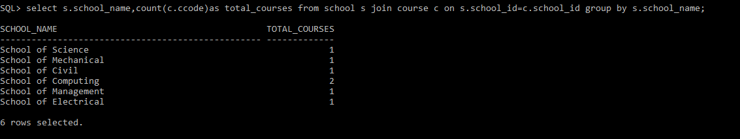
- List the students who have registered more than 2 courses
Query:
SQL> select s.sname,c.cname,f.fname,csf.grade from course_student_faculty csf join student_13 s on csf.regno=s.regno join course c on csf.ccode=c.ccode join faculty f on csf.fid=f.empid;

SNAME
--------------------------------------------------
CNAME
--------------------------------------------------
FNAME GR
-------------------------------------------------- --
Amit
DBMS
Ramesh A

Bharath
Java
Suresh B

SNAME
--------------------------------------------------
CNAME
--------------------------------------------------
FNAME GR
-------------------------------------------------- --

Charan
Mechanics
Meena A

Deepa
Circuits

SNAME
--------------------------------------------------
CNAME
--------------------------------------------------
FNAME GR
-------------------------------------------------- --
Kiran A

Esha
Surveying
Anita B

Farhan

SNAME
--------------------------------------------------
CNAME
--------------------------------------------------
FNAME GR
-------------------------------------------------- --
Management
Joseph C

Gokul
DBMS
Ramesh A

7 rows selected.

Screenshot:
